**GIT Cheat Sheet**

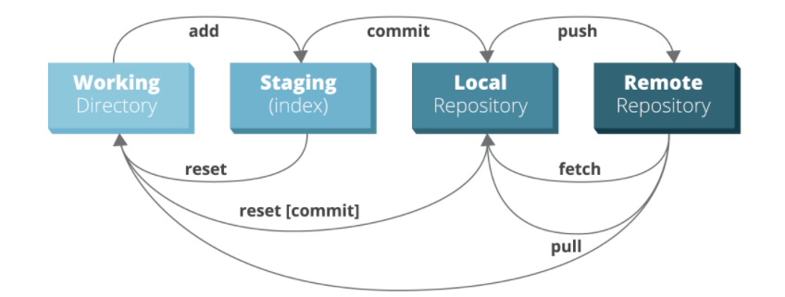

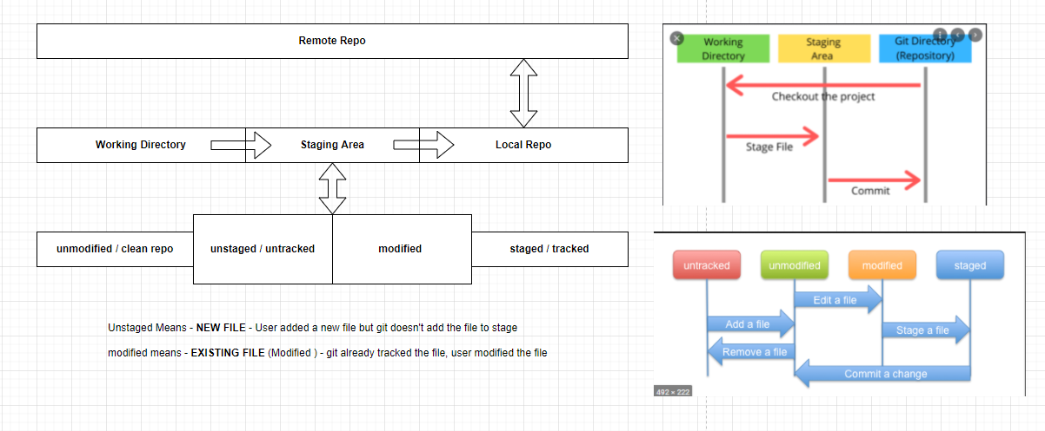

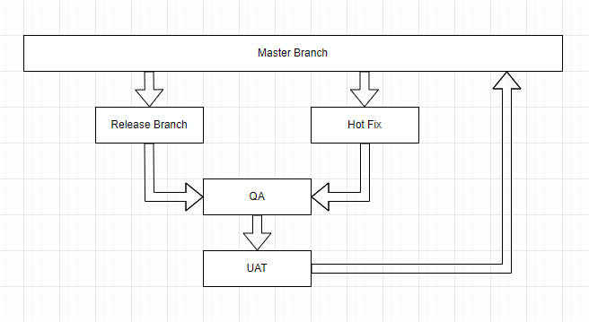

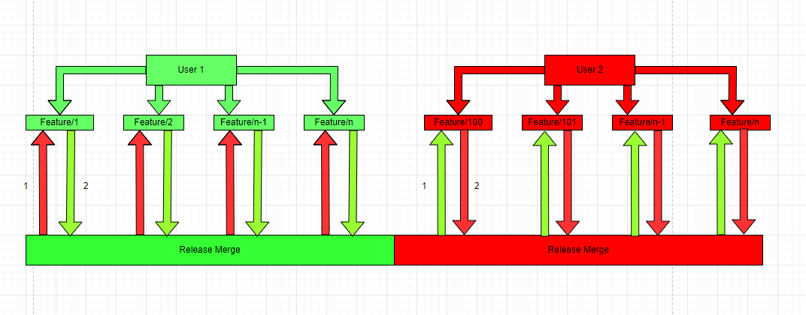

Linux commands

|  |  |
| --- | --- |
| To create a directory. | mkdir NewFolder |
| This will add an empty file in current working directory. | touch sairam.txt |
| To move to the child directory. | cd NewFolder |
| To move to the previous or parent directory. | cd .. |
| This command is to clear the terminal | clear |
| This will add a new file and insert the file content. | echo Ranjith > sairam.txt  echo Name: Ranjith > Rajagopal/Ranjith.txt |
| This will add a content in the existing file name. If file not exists it will create a new file. | echo Ranjith >> sairam.txt |
| This will delete the file on the current working directory. | rm sairam.txt |
| This will rename the file from filename to filename1. If file not found, it will throw an error. | mv sairam.txt ram.txt |
| This will move the file from one path to another path with same of different name. | mv sairam.txt newpath/sairam.txt  (OR)  mv sairam.txt newpath/ram.txt |
| To display all the content in the directory. | ls |
| To display all the content including hidden files in the directory. | ls -a |
| To delete the file or folder. | rm -rf .git  rm -rf sairam.txt  rm -rf Rajagopal/Ranjith.txt |

Git Version

|  |  |
| --- | --- |
| To display the git version installed. | git version |

Display remote details

|  |  |
| --- | --- |
| This will display the git origin details. | git remote -v |
| To add an origin | git remote add origin <https://github.com/Demo.git> |

Git Global Config

|  |  |
| --- | --- |
| Set the user name globally. | git config –-global user.name “Ranjith Rajagopal” |
| Set the user email globally. | git config –-global user.email “ranji.r@gmail.com” |

Initialize a repo

|  |  |
| --- | --- |
| Initialize a new repo. | git init |

Clone a repo

|  |  |
| --- | --- |
| Clone the repo to local directory. | git clone <https://github.com/Demo.git> |
| Clone the repo to the destination path. | git clone <https://github.com/Demo.git> C:/temp/test/ |

View Status

|  |  |
| --- | --- |
| Full status. | git status |
| Shorthand status. | git status -s |

Staging Files

|  |  |
| --- | --- |
| Stages a single file. | git add sairam.txt |
| Stages a multiple file. | git add sai.txt ram.txt |
| Stages with a pattern. | git add *.txt |
| This will stage only the modified and deleted files. | git add -u |
| Stages all the file in the current working directory and the child directory and it will ignore any files which start with “.” e.g. .gitignore. | git add * |
| Stages all the file in the current working directory and the child directory also it will add any files which begins with “.”e.g. .gitignore. | git add . |
| Stages all files in the working directory of the git. | git add -A |

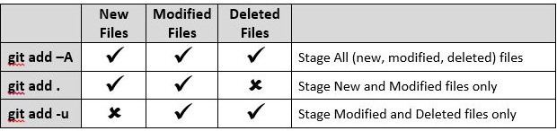

Undo the staging Change

|  |  |
| --- | --- |
| Remove the changes in working directory | git restore sairam.txt  **or**  git restore . |
| When we add the changes behind the scenes git add a temporary head. This command will remove the temporary head. Note: This is not useful command. | git reset --soft |
| This command will remove the temporary head and move the files to working directory. This command will mark the file as untracked or unmodified. | git reset --mixed |
| This command will permanently remove the files both from staging and working area. | git reset –-hard |
| This command will undo the staging changes for one file. Meaning this command will change the file status from staging area to working directory. | git reset sairam.txt  OR  git reset HEAD –- sairam.txt |
| Clear all the files on the staging area. | git clean --f |

Commit the files

|  |  |
| --- | --- |
| This command will commit the files in the current directory. Meaning it will push the file from staging area to git repo. | git commit -m “Initial Commit” |
| This command will commit the files only from the staging area. It will skip any files available on working directory. | git commit -am “Initial commit” |
| This command will delete the following commits from the git. **DON’T USE THIS COMMAND**.  Please be aware the following commit shouldn’t be pushed to remote. | git reset –-hard f6hg6t3y |
| This will revert the last two commits. | git revert HEAD~2 |
| This command will keep the history and it will revert to the older commit. This command will preserve the older commit history. | git revert f6hg6t3y |

To view the detailed commit

|  |  |
| --- | --- |
| Shows the given commit. | git show 921a2ff |
| Shows the last commit. | git show HEAD |
| Two steps before the last commit. | git show HEAD~2 |
| Shows the version of file.js stored in the last commit. | git show HEAD:file.js |

View log

|  |  |
| --- | --- |
| Full log status. | git log |
| Shorthand log status. | git log –-oneline |
| Shorthand log status with last 5 commits. | git log –-oneline -5 |
| To view the log in reverse order (from first commit to last commit). | git log --reverse |

Branch

|  |  |
| --- | --- |
| To create new branch. | git branch branchname  OR  git branch newbranchname oldbranchname  OR  git switch bugfix |
| To show all branch. | git branch |
| To checkout to new branch. | git checkout branchname |
| Creates and switches. | git switch -C bugfix |
| To delete the branch. | git branch -d branchname |

Push

|  |  |
| --- | --- |
| To push the changes to remote. | git push origin master |
| To Push the changes to upstream. | git push upstream master |

Stash

|  |  |
| --- | --- |
| Creates a new stash. This command will add the changes from working directory to stash and it will clear the working directory. | git stash  OR  git stash push -m “New tax rules” |
| Lists all the stashes. | git stash list |
| Applies the given stash to the working directory. | git stash apply 1 |
| Deletes the given stash. | git stash drop 1 |
| Deletes all the stashes. | git stash clear |

Merge

|  |  |
| --- | --- |
| Merges the bugfix branch into the current branch. | git merge bugfix |
| Creates a merge commit even if FF is possible. | git merge --no-ff bugfix |
| Performs a squash merge. | git merge --squash bugfix |
| Aborts the merge. | git merge --abort |

Cherry pick

|  |  |
| --- | --- |
| The command will act like a merge. It will merge the specific commit to the destination branch. | git cherry-pick dad47ed |

Rebase

|  |  |
| --- | --- |
| Changes the base of the current branch. | git rebase master |

Tag

|  |  |
| --- | --- |
| Tags the last commit as v1.0. | git tag v1.0 |
| Tags using a commit. | git tag v1.0 5e7a828 |
| Lists all the tags. | git tag # |
| Deletes the given tag. | git tag -d v1.0 # |

Rename or move files

|  |  |
| --- | --- |
| This command will remove the files from working directory and staging area. | git mv fileone.js filetwo.js |

Remove Files

|  |  |
| --- | --- |
| This command will remove the files from working directory and staging area. | git rm file.js |
| This command will remove files only from staging area. | git rm –-cached file.js |
| This command will remove all the folder and it sub directories recursively (-r means recursive). | git rm -r --cached myFolder  OR  git rm -rf <directory_name> |